**Assignment No : 01**

**Problem Statement : Create the following tables using the schema given below and insert given data set accordingly.**

**1. Client_Master (Used to store client information)**

**2. Product_Master (Used to store product information)**

**3. Salesman_Master (Used to store salesman working for company)**

**4. Sales_Order (Used to store client’s orders)**

**5. Sales_Order_Details (Used to store client’s orders with details of each product ordered)**

**1) client_master**

SQL> CREATE TABLE Client_Master (

2 Client_no VARCHAR2(6) PRIMARY KEY CHECK (Client_no LIKE 'C%'),

3 Name VARCHAR2(30) NOT NULL,

4 Address1 VARCHAR2(30),

5 Address2 VARCHAR2(30),

6 City VARCHAR2(15),

7 State VARCHAR2(15),

8 Pincode NUMBER(6),

9 Balance_due NUMBER(10,2)

10 );

Table created.

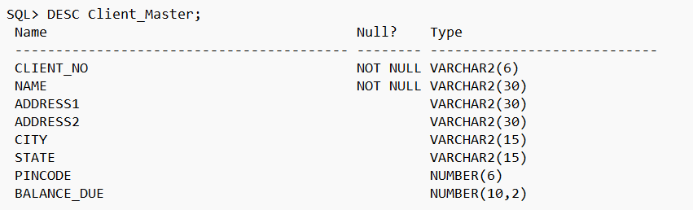

SQL> INSERT INTO client_master VALUES('C001','Ivan Bayross','P-76','Worli','Bombay','Maharashtra',400054,15000);

1 row created.

SQL> INSERT INTO client_master VALUES('C002','Vandana Satiwala','128','Adams Street','Madras','Tamil Nadu',780001,0);

1 row created.

SQL> INSERT INTO client_master VALUES('C003','Pramada Jaguste','157','Gopalpur','Kolkata','West Bengal',700058,5000);

1 row created.

SQL> INSERT INTO client_master VALUES('C004','Basu Navindgi','A/12','Nariman','Bombay','Maharashtra',400056,0);

1 row created.

SQL> INSERT INTO client_master VALUES('C005','Ravi Shreedharan','B/34','Rajnagar','Delhi','Delhi',100001,2000);

1 row created.

SQL> INSERT INTO client_master VALUES('C006','Rukmini','Q-12','Bandra','Bombay','Maharashtra',400050,0);

1 row created.

SQL> set linesize 5000;

SQL> select * from Client_Master;

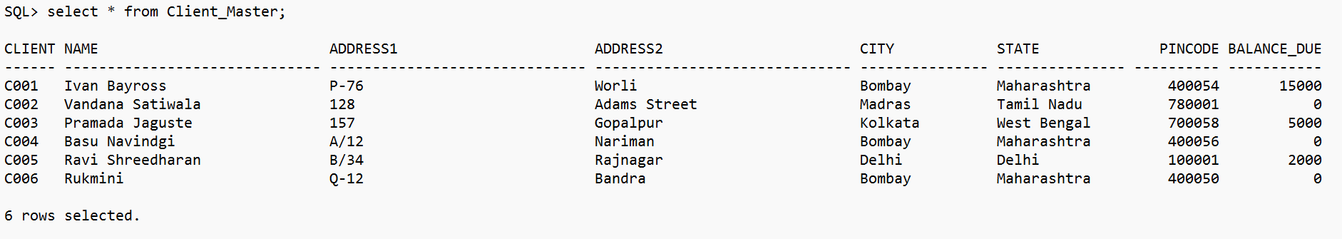

SQL> commit;

Commit complete.

**2) Product_Master**

SQL> CREATE TABLE Product_Master(

2 Product_no VARCHAR2(6) PRIMARY KEY CHECK (Product_no LIKE 'P%'),

3 Description VARCHAR2(40) NOT NULL,

4 Profit_percent NUMBER(4,2) NOT NULL,

5 Unit_measure VARCHAR2(10) NOT NULL,

6 Qty_on_hand NUMBER(8) NOT NULL,

7 Reorder_level NUMBER(8) NOT NULL,

8 Sell_price NUMBER(8,2) NOT NULL CHECK (Sell_price>0),

9 Cost_price NUMBER(8,2) NOT NULL, CHECK (Cost_PRICE>0)

10 );

Table created.

SQL> desc Product_Master;

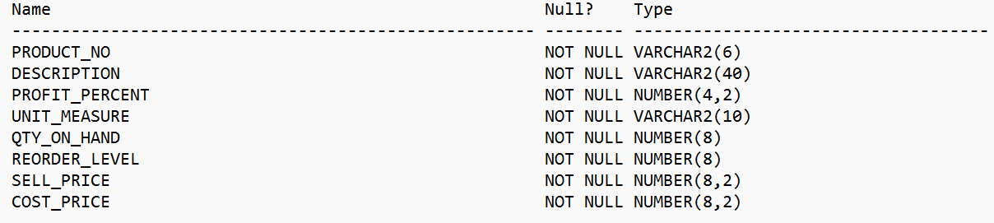

SQL> INSERT INTO Product_Master VALUES ('P00001','1.44 Floppies',5,'Piece',100,20,525,500);

1 row created.

SQL> INSERT INTO Product_master VALUES('P03453','Monitors',6,'Piece',10,3,12000,11280);

1 row created.

SQL> INSERT INTO Product_master VALUES('P06734','Mouse',5,'Piece',20,5,1050,100);

1 row created.

SQL> INSERT INTO Product_master VALUES('P07865','1.22 Floppies',5,'Piece',100,20,525,500);

1 row created.

SQL> INSERT INTO Product_master VALUES('P07868','Keyboard',2,'Piece',10,3,3150,3050);

1 row created.

SQL> INSERT INTO Product_master VALUES('P07885','CD Drive',2.5,'Piece',10,3,5250,5100);

1 row created.

SQL> INSERT INTO Product_master VALUES('P07965','540 HDD',4,'Piece',10,3,8400,8000);

1 row created.

SQL> INSERT INTO Product_master VALUES('P07975','1.44 Drive',5,'Piece',10,3,1050,900);

1 row created.

SQL> INSERT INTO Product_master VALUES('P08865','1.22 Drive',5,'Piece',2,3,1025,850);

1 row created.

SQL> set linesize 5000;

SQL> select* from Product_Master;

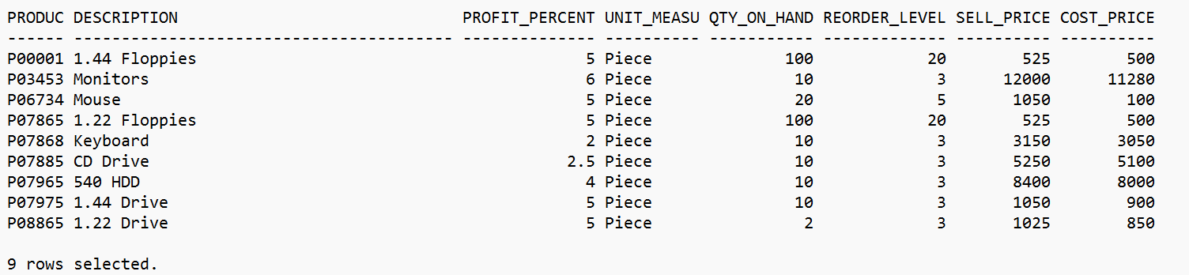

SQL> commit;

Commit complete.

**3) Salesman_Master**

SQL> CREATE TABLE Salesman_Master (

2 Salesman_no VARCHAR2(6) PRIMARY KEY CHECK (Salesman_no LIKE 'S%'),

3 Salesman_name VARCHAR2(30) NOT NULL,

4 Address1 VARCHAR2(30) NOT NULL,

5 Address2 VARCHAR2(30),

6 City VARCHAR2(20),

7 Pincode NUMBER(8),

8 State VARCHAR2(20),

9 Sal_amt NUMBER(8,2) NOT NULL CHECK (Sal_amt > 0)

10 );

Table created.

SQL> desc Salesman_Master;

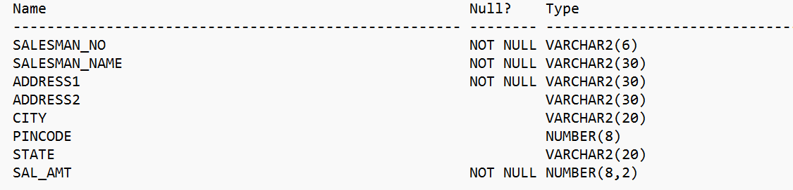

SQL> INSERT INTO Salesman_master VALUES('S001','Kiran','A/14','Worli','Bombay',400002,'Maharastra',3000);

1 row created.

SQL> INSERT INTO Salesman_master VALUES('S002','Manish','65','Nariman','Bombay',400001,'Maharastra',3000);

1 row created.

SQL> INSERT INTO Salesman_master VALUES('S003','Ravi','P-7','Bandra','Bombay',400032,'Maharastra',3000);

1 row created.

SQL> INSERT INTO Salesman_master VALUES('S004','Asish','A/5','Juhu','Bombay',400044,'Maharastra',3000);

1 row created.

SQL> select* from Salesman_Master;

SQL> commit;

Commit complete.

**4) Sales_Order**

SQL> CREATE TABLE Sales_Order

2 (

3 Order_no varchar(6),

4 Order_date DATE,

5 Client_no varchar2(6) ,

6 Salesman_no varchar2(6) ,

7 Delivery_type char(1) Default 'F',

8 Bill_y_n char(1),

9 Delivery_date DATE,

10 Order_status varchar2(10),

11 Constraint salesorder_pk PRIMARY KEY(Order_no),

12 Constraint salesorder_ck1 CHECK(Order_no LIKE 'O%'),

13 Constraint salesorder_ck2 CHECK(Delivery_type IN ('P','F')),

14 Constraint salesorder_ck3 CHECK(Delivery_date>=Order_date),

15 Constraint salesorder_ck4 CHECK(Order_status IN ('InProcess','Fullfilled','BackOrder','Cancelled'))

16 );

Table created.

SQL> desc Sales_Order;

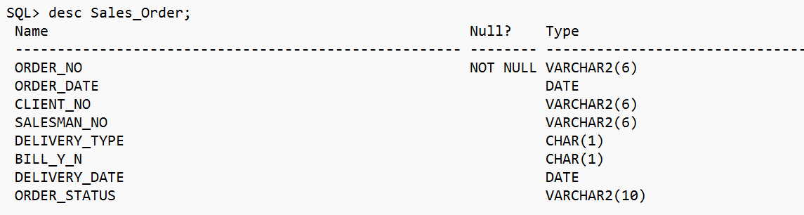

SQL> INSERT INTO Sales_Order VALUES ('O19001', TO_DATE('12-Jan-96', 'DD-Mon-YY'), 'C001', 'S001', 'F', 'N', TO_DATE('20-Jan-96', 'DD-Mon-YY'), 'InProcess');

1 row created.

SQL> INSERT INTO Sales_Order VALUES ('O19002', TO_DATE('25-Jan-96', 'DD-Mon-YY'), 'C002', 'S002', 'P', 'N', TO_DATE('27-Jan-96', 'DD-Mon-YY'), 'BackOrder');

1 row created.

SQL> INSERT INTO Sales_Order VALUES ('O46865', TO_DATE('18-Feb-96', 'DD-Mon-YY'), 'C003', 'S003', 'F', 'Y', TO_DATE('20-Feb-96', 'DD-Mon-YY'), 'Fullfilled');

1 row created.

SQL> INSERT INTO Sales_Order VALUES ('O19003', TO_DATE('03-Apr-96', 'DD-Mon-YY'), 'C001', 'S001', 'F', 'Y', TO_DATE('07-Apr-96', 'DD-Mon-YY'), 'Fullfilled');

1 row created.

SQL> INSERT INTO Sales_Order VALUES ('O46866', TO_DATE('20-May-96', 'DD-Mon-YY'), 'C004', 'S002', 'P', 'N', TO_DATE('22-May-96', 'DD-Mon-YY'), 'Cancelled');

1 row created.

SQL> INSERT INTO Sales_Order VALUES ('O19008', TO_DATE('24-May-96', 'DD-Mon-YY'), 'C005', 'S004', 'F', 'N', TO_DATE('26-May-96', 'DD-Mon-YY'), 'InProcess');

1 row created.

SQL> select * from Sales_Order;

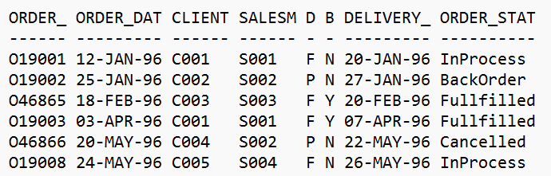

6 rows selected.

SQL> alter table Sales_Order add constraint salesorder_fk1 foreign key(Client_no) references Client_Master(Client_no);

Table altered.

SQL> alter table Sales_Order add constraint salesorder_fk2 foreign key(Salesman_no) references Salesman_Master(Salesman_no);

Table altered.

SQL> commit;

Commit complete.

**5) Sales_Order_Details**

SQL> create table Sales_Order_Details

2 (

3 Order_no varchar2(6),

4 Product_no varchar2(6),

5 Qty_ordered number(8),

6 Qty_disp number(8),

7 Product_rate number(10,2)

8 );

Table created.

SQL> desc sales_order_details;

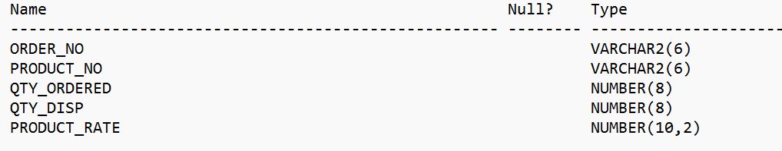

SQL> INSERT INTO Sales_Order_Details VALUES('O19001','P00001',4,4,525);

1 row created.

SQL> INSERT INTO Sales_Order_Details VALUES('O19001','P07965',2,1,8400);

1 row created.

SQL> INSERT INTO Sales_Order_Details VALUES('O19001','P07885',2,1,5250);

1 row created.

SQL> INSERT INTO Sales_Order_Details VALUES('O19002','P00001',10,0,525);

1 row created.

SQL> INSERT INTO Sales_Order_Details VALUES('O46865','P07868',3,3,3150);

1 row created.

SQL> INSERT INTO Sales_Order_Details VALUES('O46865','P07885',3,1,52500);

1 row created.

SQL> INSERT INTO Sales_Order_Details VALUES('O46865','P00001',10,10,525);

1 row created.

SQL> INSERT INTO Sales_Order_Details VALUES('O46865','P03453',4,4,1050);

1 row created.

SQL> INSERT INTO Sales_Order_Details VALUES('O19003','P03453',2,2,1050);

1 row created.

SQL> INSERT INTO Sales_Order_Details VALUES('O19003','P06734',1,1,12000);

1 row created.

SQL> INSERT INTO Sales_Order_Details VALUES('O46866','P07965',1,0,8400);

1 row created.

SQL> INSERT INTO Sales_Order_Details VALUES('O46866','P07975',1,0,1050);

1 row created.

SQL> INSERT INTO Sales_Order_Details VALUES('O19008','P00001',10,5,525);

1 row created.

SQL> INSERT INTO Sales_Order_Details VALUES('O19008','P07975',5,3,1050);

1 row created.

SQL> select * from Sales_Order_Details;

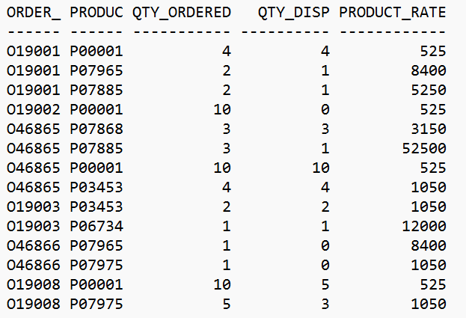

14 rows selected.

SQL> alter table Sales_Order_Details add constraint sales_order_details_fk1 foreign key(Order_no) references Sales_Order(Order_no);

Table altered.

SQL> alter table Sales_Order_Details add constraint sales_order_details_fk2 foreign key(Product_no) references Product_Master(Product_no);

Table altered.

SQL> commit;

Commit complete.